Instructions for using turnitin.com
- Turnitin.com has excellent training videos and lots of places to search for help. Before emailing me with any issues, be sure that you have tried to solve the problem by exploring the website first.

- The essay is due by August 1 at 10:00 pm without exception. I would like to have time to review your work before school begins. You have a whole summer ahead of you; you can submit the essay any time of any day before August 1. Plan accordingly.

- If you do have technical issues with Turnitin.com, I would recommend that you contact me well before August 1. I travel quite a bit during the summer, and I don’t usually have a plan. I may be out of town, out of contact, or otherwise not able to reply back to help you.

- If you do not have access to the Internet over the summer, find a friend who can help you, use a smart phone, or get a library card and use the computers at the public library. All of the essay assignments for Honors 9 are submitted using Turnitin.com, so you will need to plan for Internet access outside of school.

Turnitin.com Training Link video: http://www.turnitin.com/en_us/training/student-training
Class id: 10046837
Class enrollment password: mohawk
I find the training videos on Turnitin.com to be very helpful and easy to understand. If you are new to using Turnitin.com, start the process of creating your new account by viewing the video I’ve linked to here.
I’ve also attached written instructions for those you who prefer to read the instructions ahead of time.

written instructions
Creating a New Account
- Go to the website www.turnitin.com
- At the top left corner of the screen, you will see a blue Log In button. DO NOT click on this. Instead click on the small link next to it where it says, “Create Account.”
(Click here!)
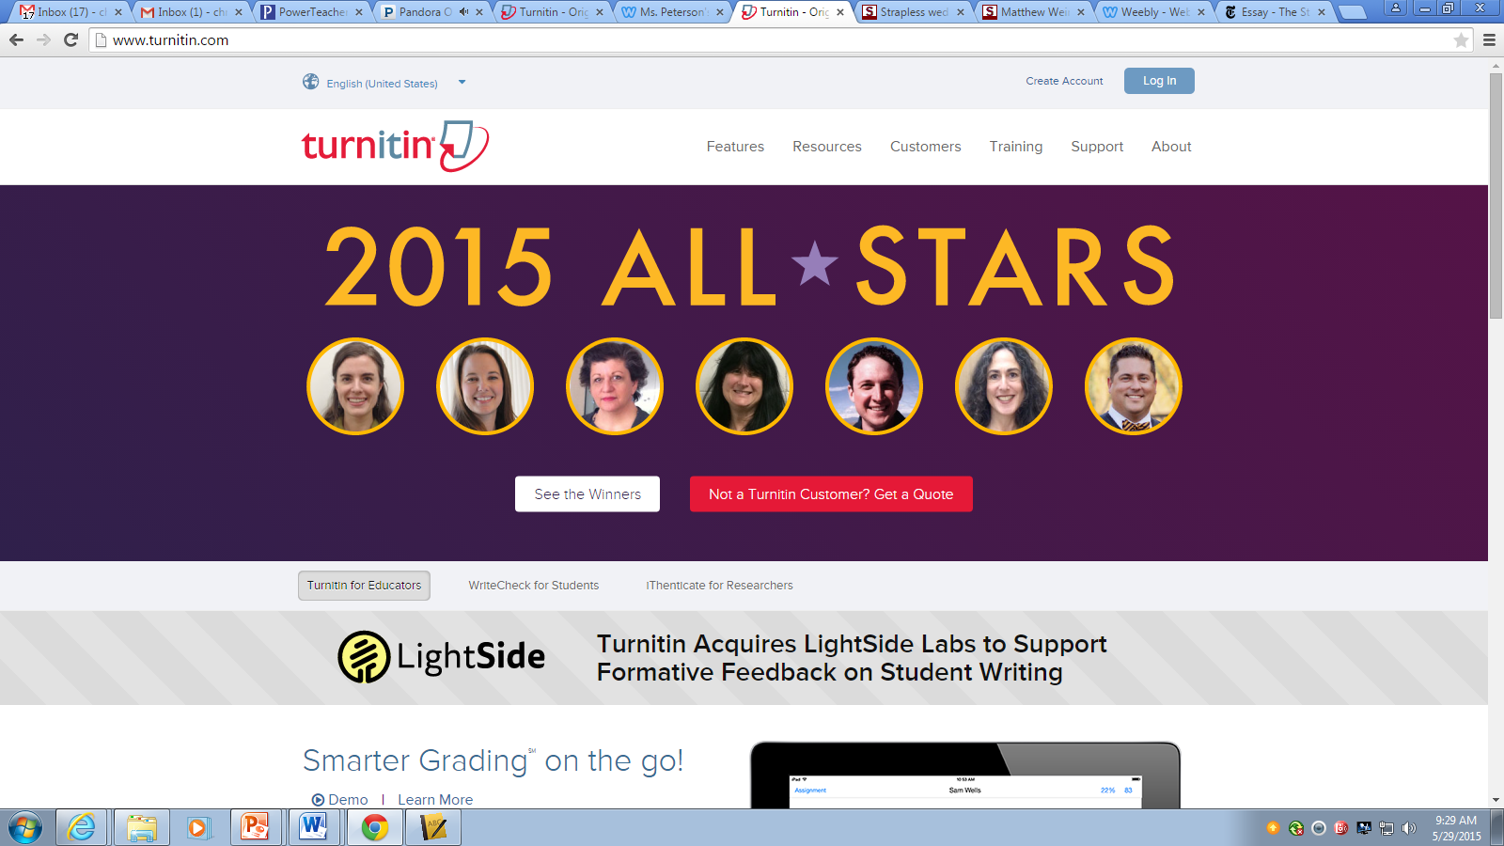

- Again, Turnitin.com makes it confusing for people. It looks like you should enter your email address right away. DON’T! Instead, scroll down a bit and look for “Create a New Account.” Then click on the link for “Student.”
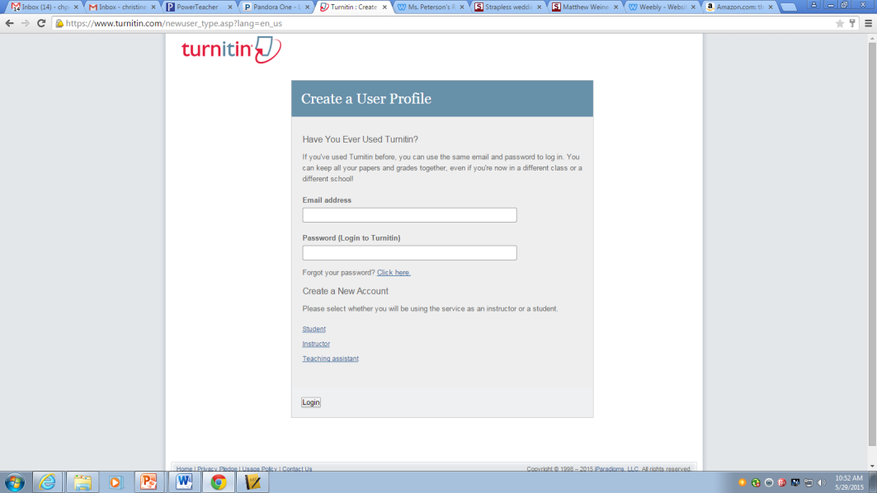
Click here!

- Finally! You can now create a new account. So here’s what you need to know:

The Class ID for your class is 10046837.

The Class Enrollment Password is mohawk. (no capital letters).

- Now you may enter your information—first and last name, email address, and a password. BE SURE THAT ALL OF THIS IS CORRECT BEFORE SUBMITTING!

- I strongly recommend that you use your school email address for this account. Select a password that you can remember, and WRITE IT DOWN!

- I even more strongly recommend that when selecting a “Secret Question” for your password recovery that you select a question that is a verifiable fact, not your opinion. For example, the title of your favorite book may change, whereas your ID number will never change.

- Click the “I agree” button at the bottom of the screen and you’re done! Yippee!

Submitting a Paper
- Log in to your turnitin account.

- Click on the class name in the middle of the screen. You will see only one class name: Honors 9 English Summer.

- You will see just one assignment listed. Click on the blue Submit button on the right side of the screen, and then simply follow the instructions. You will be able to load a file from Microsoft Word, Dropbox, or from Google Drive.

- Be sure to click on the Confirm button after you have submitted the essay. If you do not receive a ticket number and an email that confirms your submission, it did not upload correctly.

- You may submit and resubmit your essay as many times as you would like to before the due date.

