The Behavior Standard of Lhasa Apsos
Every dog breed has a “standard,” which just means that there’s a certain way that all dogs of a particular breed are supposed to look and behave. We wouldn’t expect a Great Dane to be a tiny little dog, and we wouldn’t expect a Labrador Retriever to be aggressive and mean to strangers. Because of breed standards, we know that Great Danes are expected to be very big and that Labrador Retrievers are probably going to be extremely friendly. The breed standard for a Lhasa Apso, besides that they are small, though not tiny, dogs, is that they are protective and loyal. Lhasa Apsos were bred by Tibetan monks over four thousand years ago to be the household guard. The larger dogs and soldiers stayed outside the walls of the city to protect inhabitants from invaders, but the Lhasa Apso was bred to be an inside dog, ready to stand and alarm the family if there was an immediate danger. Their key trait is that they’re suspicious of strangers and yet comical and loving with the people they love.
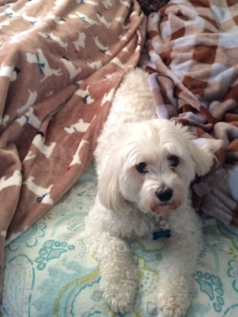
Thousands of years later and thousands of miles away, my dog, Franny Blue, shows off this breed standard. Franny is a small-ish dog, but her bark and sharpness with strangers implies that she sees herself much larger than she is. Every visitor, every car, every deliveryman, and every squirrel is cause for alarm. At night, she sleeps beside me and ignores the train whistles and general noises of the household (furnace, pipes, etc), but, without fail, will quickly stir to attention, growl a bit, and perhaps even sharply bark once or twice if an unusual noise wakes her. Believe it not, this doesn’t happen very often. She knows which noises should cause alarm and which ones can be ignored.
Like many Lhasas, Franny is very picky about who she will accept as family. Until a new person is accepted as “family,” she is on guard: she barks, she backs away, she protects me. Once she does accept you, she loves you wholeheartedly. This is a picture of her protecting my parents, but also willing to pose for the camera. Franny follows the breed standard of a Lhasa Apso: she’s a small, protective, and loyal dog.

